**Activity 27**

**NAME : M.Varshini COURSE : Mobile Computing Reg No : 192421293 COURSE CODE: ITA0302**

27.Use Figma to create an interactive presentation comparing the Core Video framework in iOS and the multimedia framework in Android.

**Aim:**

Create an interactive presentation comparing the Core Video framework in iOS and Android using Figma

**Procedure:**

1.Define Presentation Structure

2.Create a Figma Project

3.Design Visual Elements

4.Make it Interactive

5.Add Annotations and Explanations

6.Incorporate Multimedia

7.Storyboard Animation

8.Test the Prototype

9.Collaborate and Gather Feedback

10.Finalize and Share

**Design:**

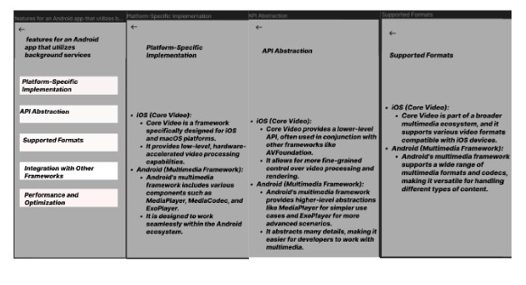

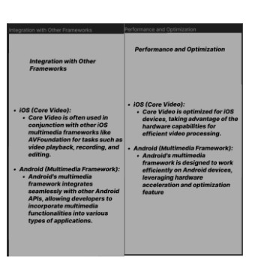

**Prototype:**

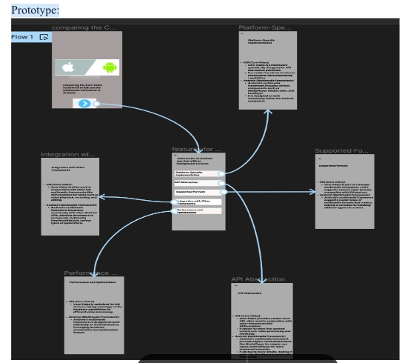

**Result:**

Hence an interactive presentation comparing the Core Video framework in iOS and Android using Figma have been created successfully